The Process of Forecasting

1-

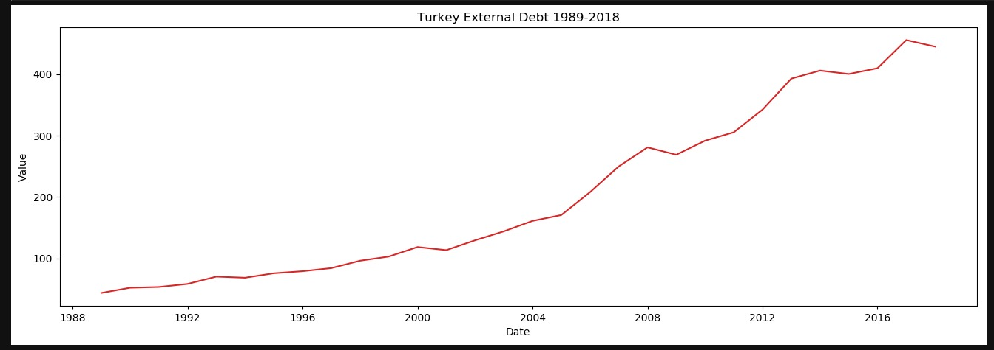

“Turkey External Debt” from 1989 to 2018 is showing in the graph. As you see, the data is not stationay and its variance is not high. Also, there is no constnt average value, but the trend is rising. KPSS and ADF tests have been applied to mesure the stationay.

2-

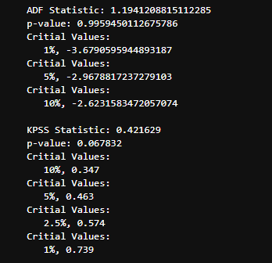

According to the KPSS test, our data is not stationary because the p value of the test is higher than 0.05. Because we understand from the graph that there is a rising trend we have applied detrending method to eliminate it

3-

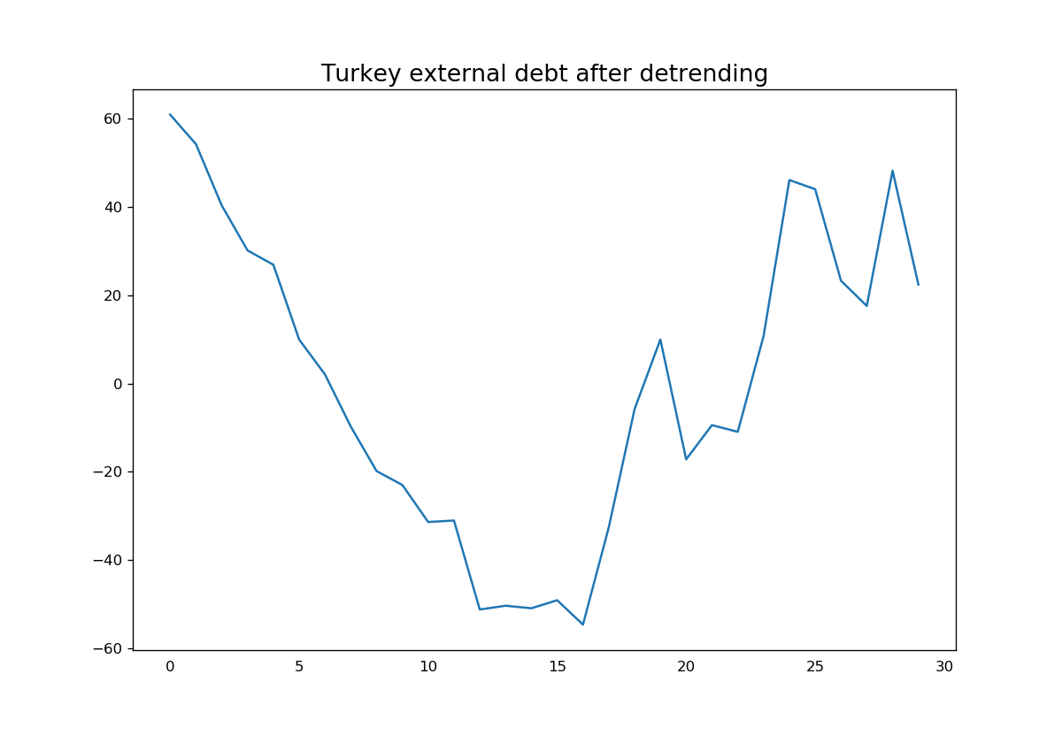

And now, our data became stationary and the trend has been eliminated. Thus, it is suitable for forecasting.

4-

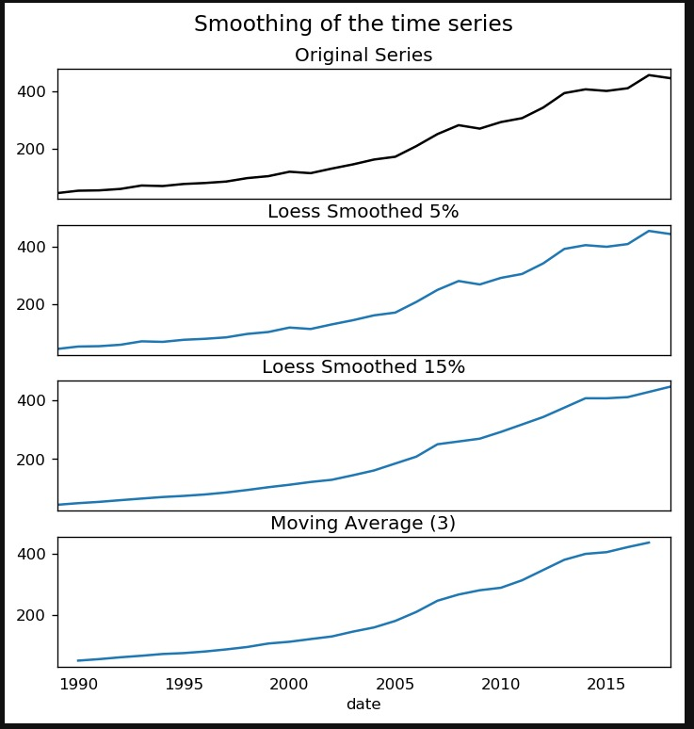

We have used Loess Smoothing and Moving Average Methods for the forecasting. According to the situation, Turkey’s external debt is rising for both of methods. Because the results from these two methods are parallel each other, one of them can be used for the forecasting.